Preparing a Linux Ubuntu 20 OS for Bootcamp

Part01 NodeJS & NPM

1. Open a terminal window to run the following commands
2. Update your linux box:  
   sudo apt update  
    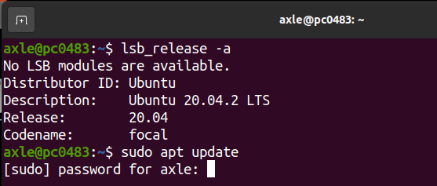
3. This is the command to install NodeJS after the update  
   sudo apt install nodejs
4. Install npm once Node is done

sudo apt install npm

1. (Optional) Check for the versions by running the following commands:  
   nodejs -v and

npm -v

Part02 MongoDB

1. (Optional) If you do not have cURL install, please install it in order to install the community version of MongoDB  
   sudo apt install curl

### Use cURL to import a public key used by npm (you may also use Wget)

wget -qO - https://www.mongodb.org/static/pgp/server-4.4.asc | sudo apt-key add -

### Create a list file for Ubuntu in a special folder in the apt directory echo "deb [ arch=amd64,arm64 ] https://repo.mongodb.org/apt/ubuntu focal/mongodb-org/4.4 multiverse" | sudo tee /etc/apt/sources.list.d/mongodb-org-4.4.list

1. Do another update, follow the command in #2 above
2. Now install the latest version of MongoDB

sudo apt-get install -y mongodb-org

1. For the community version, you will need to start the service manually  
   sudo systemctl start mongod
2. Check the status of the MongoDB service  
   sudo systemctl status mongod

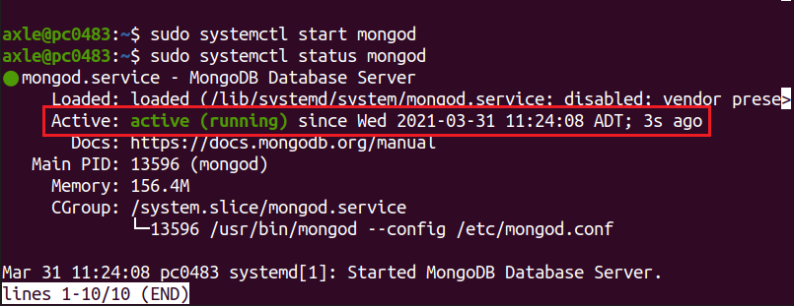

Part03 Visual Studio Code

1. Finally install Visual Studio code using *snap*. If Snaps is not installed on your machine, the following command will install it first then VS Code, its automatic

sudo snap install --classic code